FSAD WEEK 2:
CREATE TABLE:
CREATE TABLE student; (
student_id INT PRIMARY KEY,
student_name VARCHAR(100) NOT NULL,
email VARCHAR(100),
age INT,
gender CHAR(1),
city VARCHAR(50),
admission_date DATE,
mentor_id INT
);
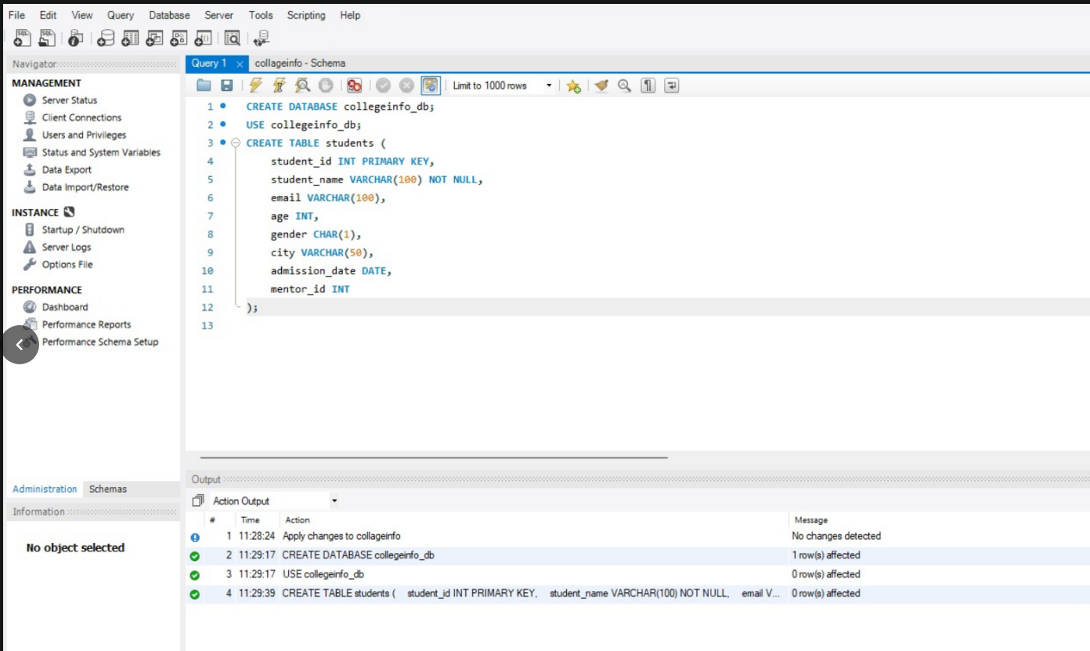
INSERT:
INSERT INTO students VALUES
(1, 'Aarav', 'aarav@gmail.com', 20, 'M', 'Delhi','2022-06-10', NULL),
(2, 'Neha','neha@gmail.com',21, 'F', 'Mumbai', '2021-07-15', 1),
(3, 'Rahul', NULL, 22, 'M', 'Delhi','2022-01-12', 1),
(4, 'Priya', 'priya@gmail.com', 20, 'F', NULL, '2023-03-20', 2),
(5, 'Karan', 'karan@gmail.com', 23, 'M', 'Pune','2021-11-01', 2),
(6, 'Anita', NULL, 21, 'F', 'Mumbai', '2022-08-05', 3);

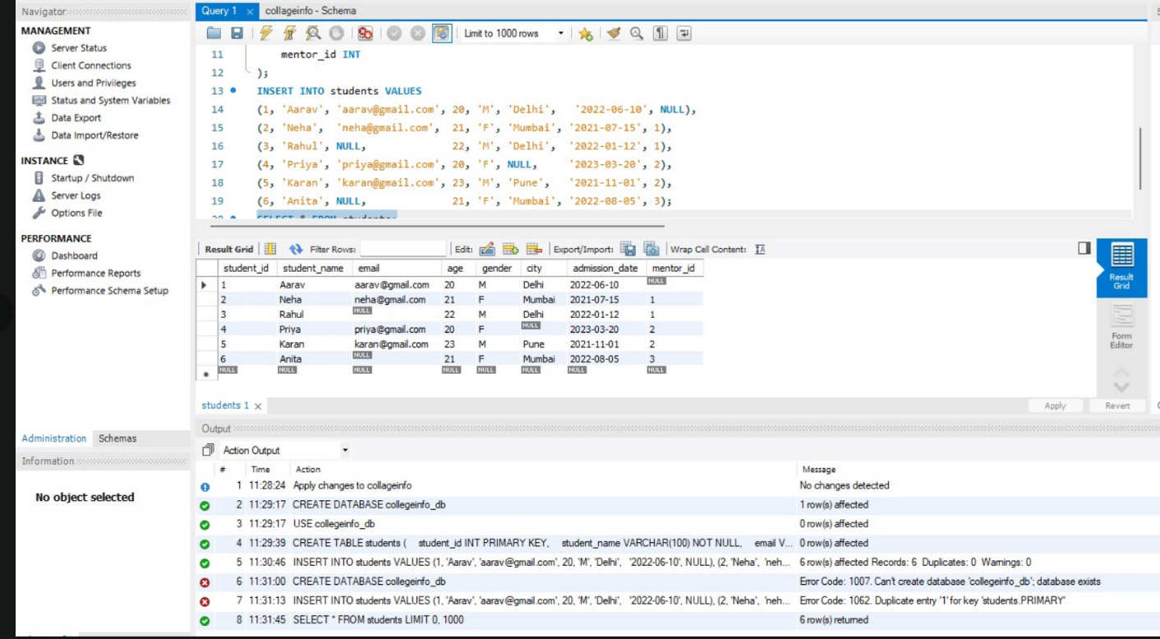
SELECT:
SELECT
student_id,
student_name,
(SELECT COUNT(*) FROM students) AS total_students
FROM students;
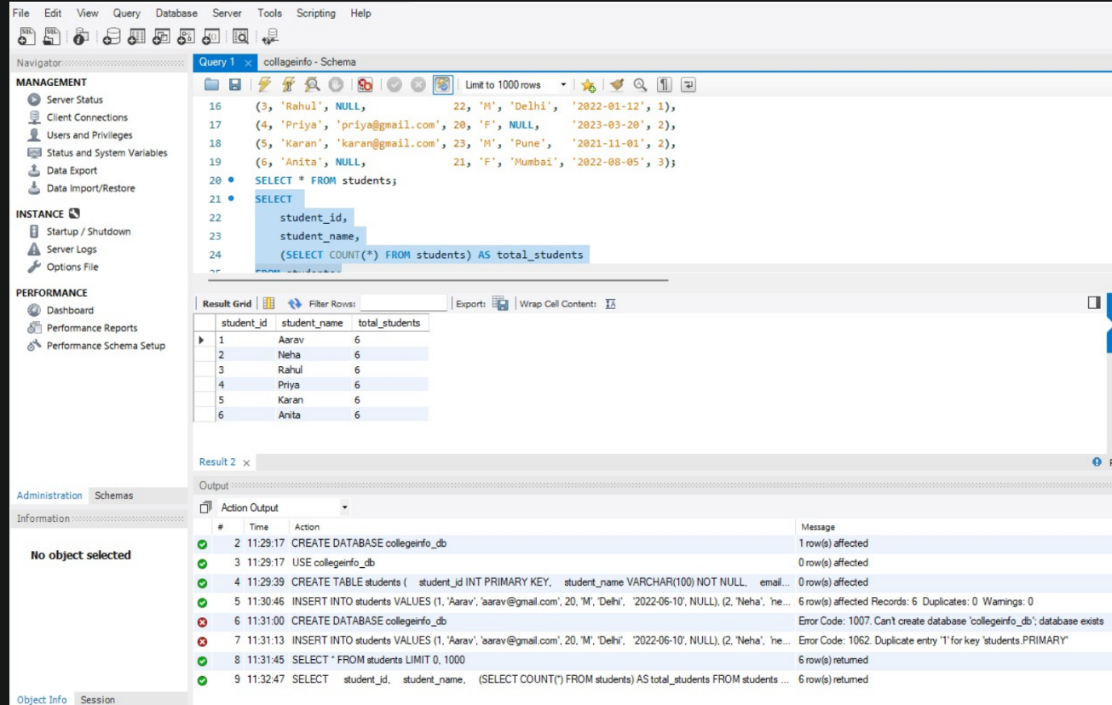
WHERE:
SELECT *
FROM students
WHERE age > (
SELECT AVG(age)
FROM students
);

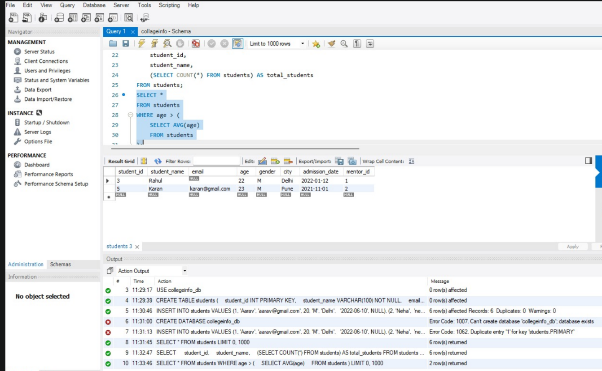
INSERT SUBQUERY:
CREATE TABLE senior_students (
student_id INT,
student_name VARCHAR(100),
age INT
);
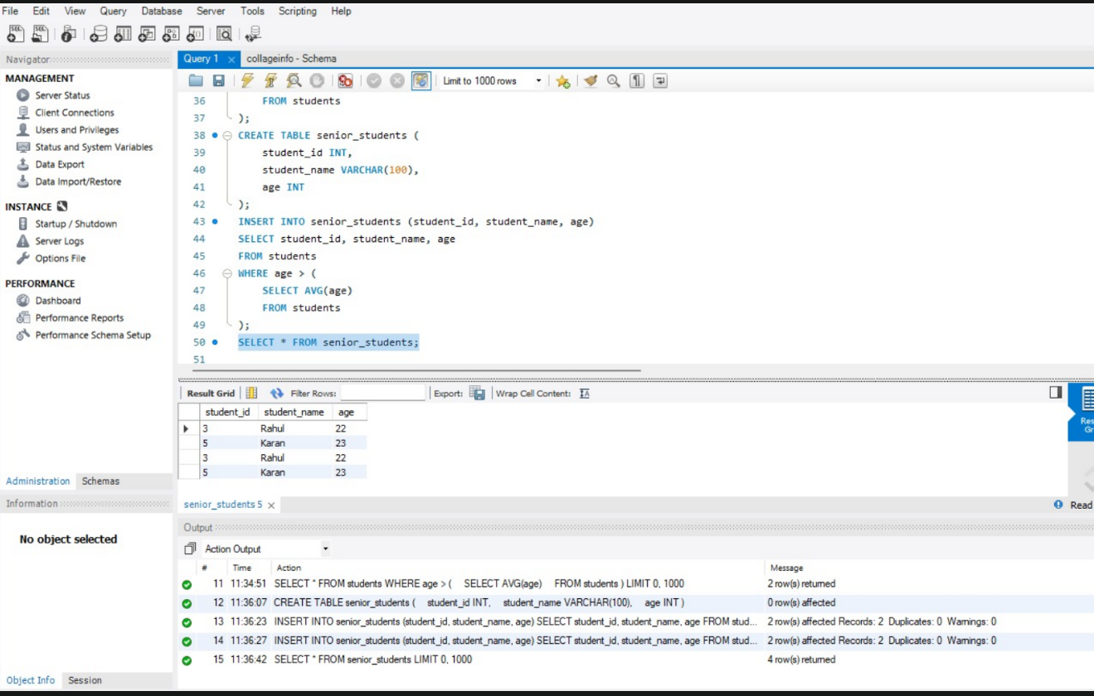
CURRENT DATE AND CURRENT TIME
INSERT INTO senior_students (student_id, student_name, age)
SELECT student_id, student_name, age
FROM students
WHERE age > (
SELECT AVG(age)
FROM students
);

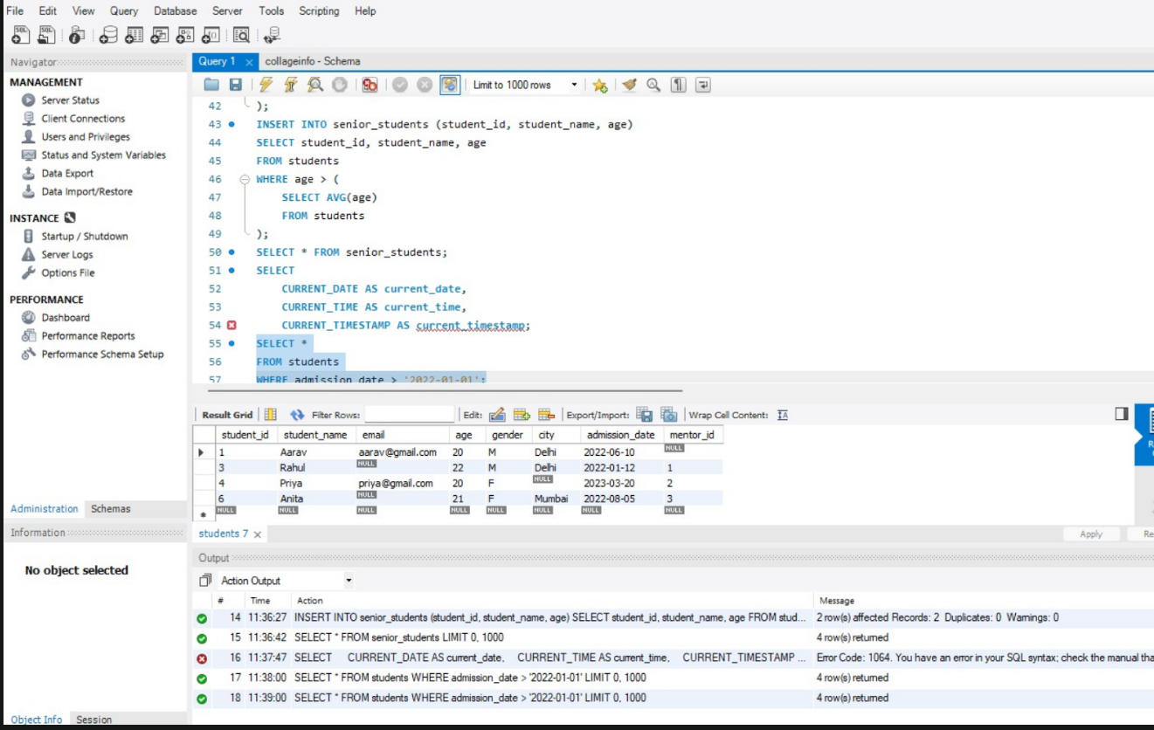
CURRENT TIME STAMP
